Practical No. 4
Aim : Create grid system for the given screen using any Design tool
Name : Danish Altaf Solkar | Class : CO - B
Enrolment no. : 24111590805 | Batch : 2

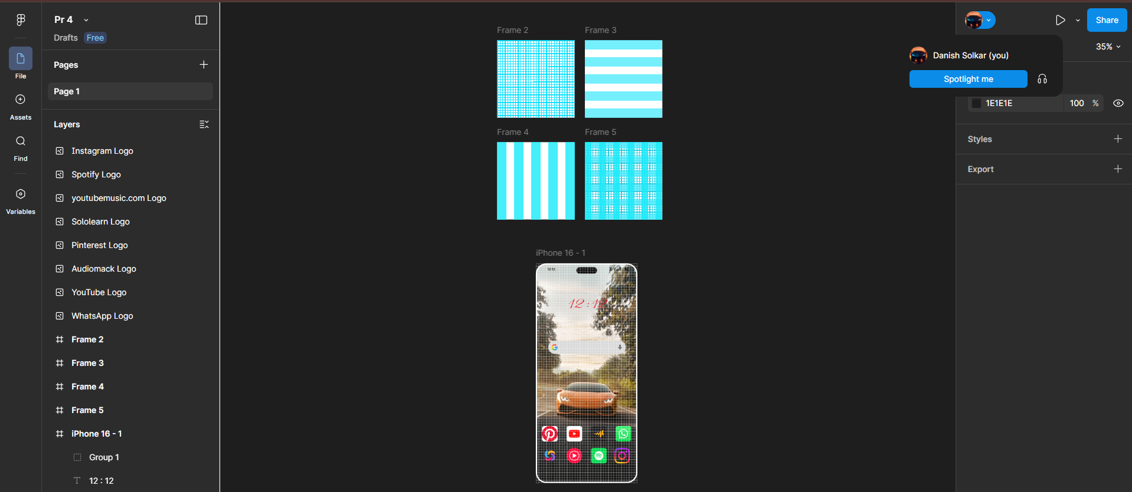
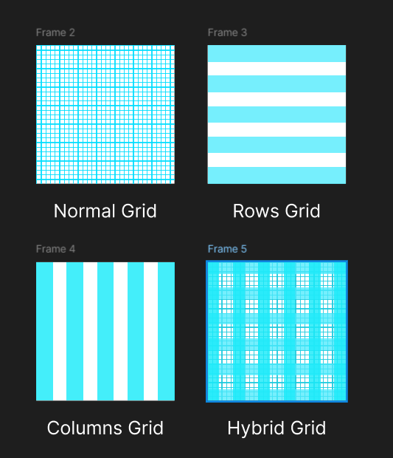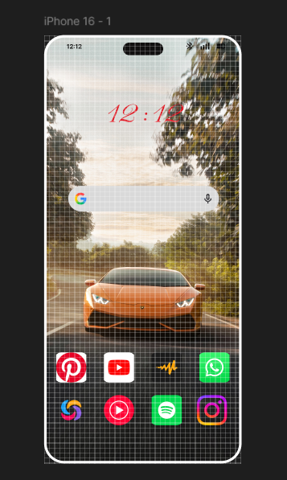
Process related  (15) | Product related  (10) | Total Marks  (25) | Signature

